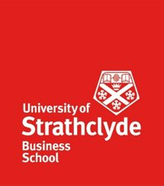
Strathclyde Business School
Investigating how, ‘relationships between business performance, managing people, and brand strategies impacts SME’s’ success
MBA Group Project
Stephanie Craig
Ahmed Mansour

Disclaimer – all answers provided will be anonymized

Q1 Tell us about your business’ marketing/branding strategy?

Q2 Over the next 5 years do you see your business expanding and in what way?

Q3 Tell us about your company’s digital presence

Q4 Does your company have clear values? What one means the most to you?

Q5 Tell us about your company’s incentive/recognition policy

Q6 How would you describe peoples morale?

Q7 Does the company encourage idea generation throughout the company?

Q8 How does your company measure performance e.g. KPI’s?

Q9 Has your business grown in the last year? If yes, in what way

