

Outstanding Performing Business

>5 & <25 Staff

Sponsored by
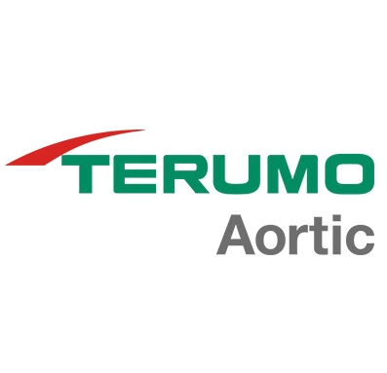

Please read the conditions of entry and guidance notes carefully before completing this form.

Closing date: NEW EXTENDED ENTRY DEADLINE MIDNIGHT 26th SEPT

Outstanding Performing Business >5 & <25 Staff Award

For smaller businesses who can demonstrate dynamism, commitment to growth and success in achieving planned objectives. Successful smaller businesses should be able to demonstrate a clearly defined vision for developing and growing the business in terms of both profitability and employment.
While demonstrating entrepreneurial characteristics, successful companies will have systems in place to measure performance effectively, particularly in terms of financial controls.
Staff development and involvement of the workforce in the growth of the business will be a key characteristic, as well as a strong focus on the needs of the customer through effective marketing strategies.
Successful companies will have customer satisfaction at the heart of their business strategy. Entrants should be able to prove a track record in customer satisfaction and continued commitment to exceeding customer expectations, recognising the contribution from staff when dealing with customers.

Conditions of entry & guidance notes
Entry is free and open to any Renfrewshire Chamber member or non-member businesses who are based in Renfrewshire

- Please complete the form digitally
- Please email the completed form back to awards@roccoawards.com
- Read the questions and answer concisely.
- Pay attention to word count limits
- Do not copy and paste from company documents or previous submissions
- Do not send in other documents, unless requested
- Submissions may be subject to requests for evidence to maintain the integrity of the awards
- Use evidence, targets and KPIs (Key Performance Indicators) where possible
- Don't use jargon or acronyms/abbreviations
- Relate it to Renfrewshire
- Think what the judges want to see & hear
- Submissions received late will not be entered
- And finally - don’t leave it to the last minute!

Outstanding Performing Business >5 & <25 Staff Award
Section 1
Full name of company: |  |  |  |  |  |  | Date company was established:
Main local address:

Web:
Name of person form completed by/for:
Job Title:
Tel: |  | Fax: |  |  |  | Email:
Type of organisation: (bold)  Manufacturing  Service  Retail  Education/Training  Voluntary  Other (Please specify): |  |  |  |  | Type of company: (bold)  Limited Company  PLC  Partnership  Association  Sole Trader  Registered Charity  Other (Please specify):
Number of employees:  Locally: |  |  | UK: |  |  |  |  | Worldwide:
Number of employees projections  2025: |  |  | 2026:
Annual turnover & profit (if available) | Last year |  |  |  | This year |  |  |  | Next year
Turnover
Profit
Brief description of the organisation / what you do

Brief description of main products and services

Principal markets supplied

Briefly, what is your vision, strategy and key objectives?

Section 2
How have you responded and adapted to the post-covid environment?

Explain how your all round business performance exceeds customer expectations.

How do you differentiate against the competition?

How do you motivate/reward staff?

How do you monitor & measure performance?

Anything else relevant you wish to share? (e.g. how do you engage with customers/awards won)

Why do you believe that your organisation deserves to win the ROCCO Award for Outstanding Performing Business (max 250 words)

Section 3
Authorisation: I have read and accepted the rules and guidelines associated with these awards, and enter this submission on my organisation's behalf.
Name
Title
Signature

All forms must be completed electronically and returned to awards@roccoawards.com

Closing date: NEW EXTENDED ENTRY DEADLINE MIDNIGHT 26th SEPT

If your application is selected for shortlisting you will be required to present to the judges at some point during the week commencing 28th October 2024.

If you have any questions regarding the completion of any aspect of the required information please contact Bob Grant on 0141 847 5450 or email awards@roccoawards.com

