**Business Leader of the Year**

Sponsored by:

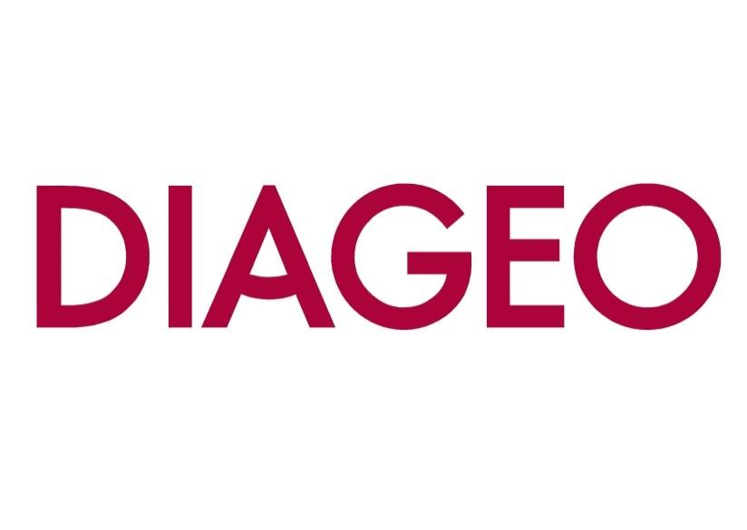

Please read the conditions of entry and guidance notes carefully before completing this form.

**Closing date: 19th SEPT**

# Business Leader of the Year Award

This award recognises the leader of a company who has done some or all of the following:

* Led the company through a difficult phase - and came out on top
* Grown the company significantly whether it be by turnover/profit/market share/staff
* Enhanced the profile of the company on a local/national or even global basis
* Through their leadership the company excels in certain areas, such as service or quality
* Enhanced the reputation of Renfrewshire

# Conditions of entry & guidance notes

**Entry is free and open to any Renfrewshire Chamber member or non-member businesses who are based in Renfrewshire**

* Please complete the form digitally
* Please email the completed form back to awards@roccoawards.com
* Read the questions and answer concisely.
* Pay attention to word count limits
* Do not copy and paste from company documents or previous submissions
* Do not send in other documents, unless requested
* Submissions may be subject to requests for evidence to maintain the integrity of the awards
* Use evidence, targets and KPIs (Key Performance Indicators) where possible
* Don't use jargon or acronyms/abbreviations
* Relate it to Renfrewshire
* Think what the judges want to see & hear
* Submissions received late will not be entered
* And finally - don’t leave it to the last minute!

# Business Leader of the Year Award

**Sponsored By Diageo**

|  |  |  |  |  |  |  |  |  |  |
| --- | --- | --- | --- | --- | --- | --- | --- | --- | --- |
| **Section 1** | | | | | | | | | |
| **Full name of company:** | | | | | | | **Date company was established:** | | |
| **Main local address:** | | | | | | | | | |
| **Web:** | | | | | | | | | |
| **Name of person form completed by/for:** | | | | | | | | | |
| **Job Title:** | | | | | | | | | |
| **Tel:** | | **Fax:** | | | | **Email:** | | | |
| **Type of organisation: (bold)**  Manufacturing  Service  Retail  Education/Training  Voluntary  Other (Please specify): | | | |  | **Type of company: (bold)**  Limited Company  PLC  Partnership  Association  Sole Trader  Registered Charity  Other (Please specify): | | | | |
| **Number of employees:**  Locally: | | | UK: | | | | | Worldwide: | |
| **Number of employees projections**  2026: | | | 2027: | | | | | | |
| **Annual turnover & profit (if available)** | **Last year** | | |  | **This year** | | | | **Next year** |
| **Turnover** |  | | |  |  | | | |  |
| **Profit** |  | | |  |  | | | |  |
| **Brief description of the organisation / what you do** | | | | | | | | | |
| **Brief description of main products and services** | | | | | | | | | |
| **Principal markets supplied** | | | | | | | | | |
| **Briefly, what is your vision, strategy and key objectives?** | | | | | | | | | |

|  |
| --- |
| **Section 2** |
| **Why does this person deserve to win Business Leader of the Year (max 250 words)** |

|  |  |
| --- | --- |
| Section 3 | |
| Authorisation: I have read and accepted the rules and guidelines associated with these awards, and enter this submission on my organisation's behalf. | |
| **Name** |  |
| **Title** |  |
| **Signature** |  |

All forms must be completed electronically and returned to [awards@roccoawards.com](mailto:awards@roccoawards.com)

**Closing date: 19th SEPT**

If you have any questions regarding the completion of any aspect of the required information please contact **Bob Grant** on **0141 847 5450** or email [awards@roccoawards.com](mailto:awards@roccoawards.com)