

Community Wealth Building

Sponsored by:
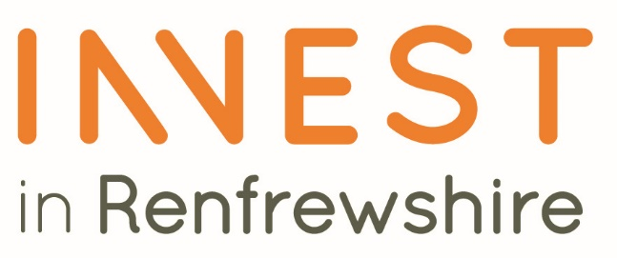

Please read the conditions of entry and guidance notes carefully before completing this form.

Closing date: 19th SEPT

Community Wealth Building Award

This award is open to organisations of all sizes who have taken an innovative and people-centered approach to supporting the local economy through utilizing their spend, assets, employment, and financial powers for local good.

Community Wealth Building is a people-based approach to local economic development that aims to add more economic benefit and community added value at a local level. The award seeks to highlight businesses which, through their inclusive business practices, contribute to improving the wellbeing and outcomes of local people and communities.

You will be able to demonstrate how you are making a significant contribution to building wealth within Renfrewshire through sustainable, inclusive, and community-driven activities, focusing on practical actions that have been taken across five key areas: local ownership, local finance and investment, local employment, local purchasing and locally owned land and assets.

You should provide evidence in at least one of the following 5 key elements of community wealth building however, examples may include more than one element:

- Local purchasing
Developing a more inclusive procurement and commissioning model so that more money stays in the local area, creating more jobs, and developing a more diverse local supply chain. Supporting community benefits ensuring that local good causes can receive additional social value from your spending.

- Local Employment
Creating more opportunities to develop local people's skills and experience to enter and / or progress within the labour market. Making your recruitment process more accessible to people with barriers to employment, paying the living wage and building progression routes accessible for all. Giving employees a voice at work, security, opportunity, fulfilment and respect.

- Local Land & Property
Supporting the development and use of underutilised, unused, or vacant spaces to create opportunities to revitalise community spaces bringing added value and social gain for those who live there.

- Local Finance
Prioritising local spending, saving, and investment, aiming to ensure that the flow of local finance directly benefits local people, communities, and businesses. Supporting long term investment in Renfrewshire to ensure future jobs, prosperity, and economic growth.

- Local Ownership
Providing opportunities and supporting the development and growth of small enterprises, community organisations, cooperatives and municipal ownership – locking wealth in place.

Conditions of entry & guidance notes
Entry is free and open to any Renfrewshire Chamber member or non-member businesses who are based in Renfrewshire

- Please complete the form digitally
- Please email the completed form back to awards@roccoawards.com
- Read the questions and answer concisely.
- Pay attention to word count limits
- Do not copy and paste from company documents or previous submissions
- Do not send in other documents, unless requested
- Submissions may be subject to requests for evidence to maintain the integrity of the awards
- Use evidence, targets and KPIs (Key Performance Indicators) where possible
- Don't use jargon or acronyms/abbreviations
- Relate it to Renfrewshire
- Think what the judges want to see & hear
- Submissions received late will not be entered
- And finally - don’t leave it to the last minute!

Community Wealth Building Award
Sponsored By Renfrewshire Council
Section 1
Full name of company: |  |  |  |  |  |  | Date company was established:
Main local address:

Web:
Name of person form completed by/for:
Job Title:
Tel: |  | Fax: |  |  |  | Email:
Type of organisation: (bold)  Manufacturing  Service  Retail  Education/Training  Voluntary  Other (Please specify): |  |  |  |  | Type of company: (bold)  Limited Company  PLC  Partnership  Association  Sole Trader  Registered Charity  Other (Please specify):
Number of employees:  Locally: |  |  | UK: |  |  |  |  | Worldwide:
Number of employees projections  2026: |  |  | 2027:
Annual turnover & profit (if available) | Last year |  |  |  | This year |  |  |  | Next year
Turnover
Profit
Brief description of the organisation / what you do

Brief description of main products and services

Principal markets supplied

Briefly, what is your vision, strategy and key objectives?

Section 2:
Describe your innovative Community Wealth Building business activities and how it supports the local economy and community

What approach does your activity support, give current examples on all that apply:
- Local purchasing
- Local employment.
- Local land and assets.
- Local finance
- Local ownership.

Describe how your Community Wealth Building business activities are measured.

Describe how the Community Wealth Building activities of your organisation have positively impacted upon your organisation , your local community and people.

Explain why your business deserves to win the Community Wealth Building ROCCO Award (max 250 words)

Section 3
Authorisation: I have read and accepted the rules and guidelines associated with these awards, and enter this submission on my organisation's behalf.
Name
Title
Signature

All forms must be completed electronically and returned to awards@roccoawards.com

Closing date: 19th SEPT

If your application is selected for shortlisting you will be required to present to the judges at some point during the week commencing 3rd Nov 2025.

If you have any questions regarding the completion of any aspect of the required information please contact Bob Grant on 0141 847 5450 or email awards@roccoawards.com

