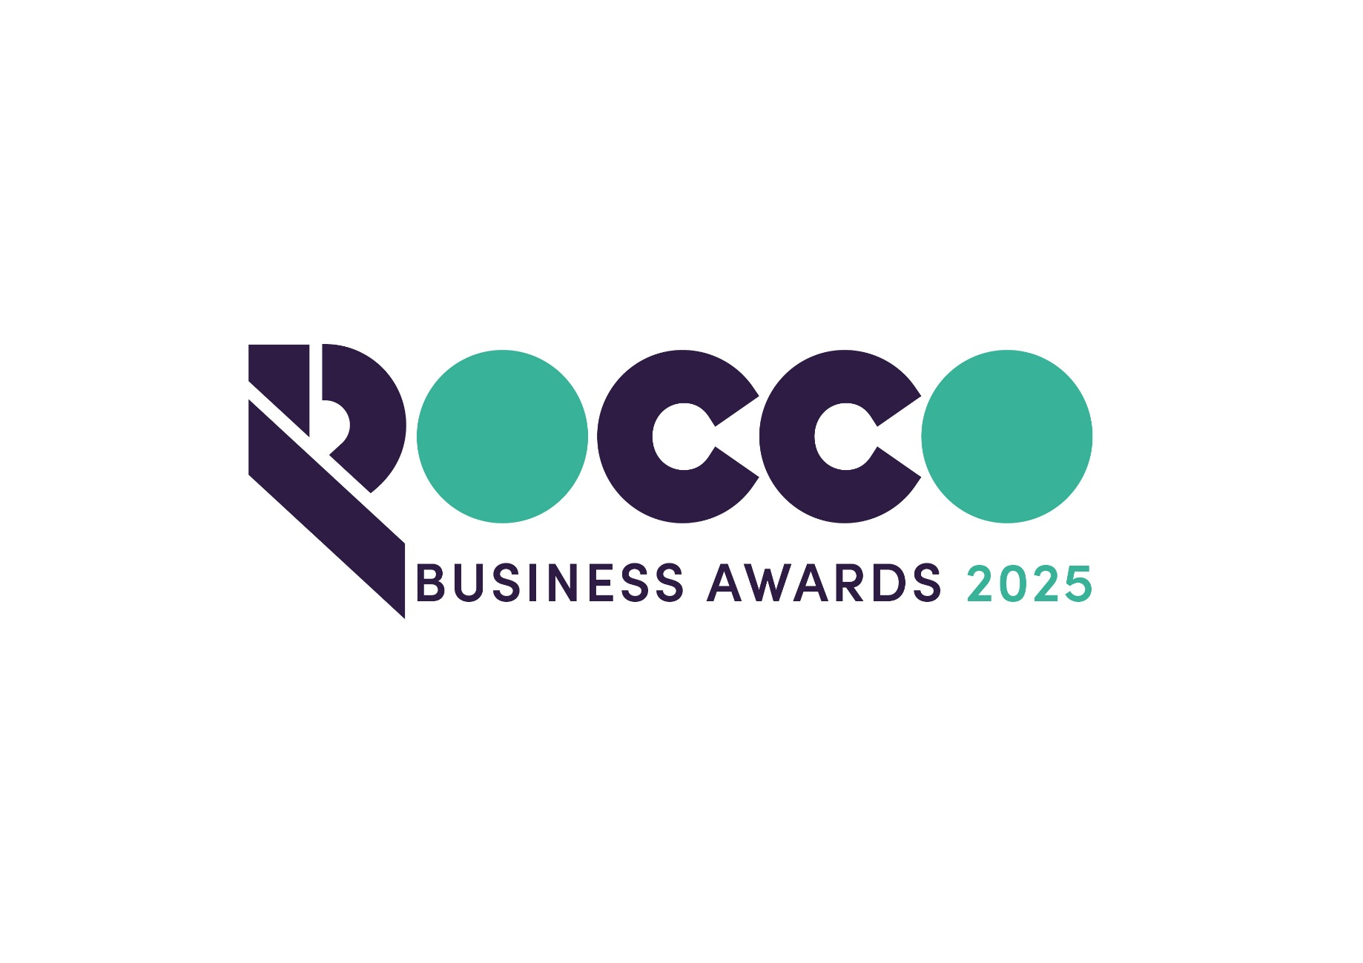

Environmental Sustainability

Sponsored by:



Please read the conditions of entry and guidance notes carefully before completing this form.

Closing date: 19th Sept 2025.

Environmental Sustainability Award

This Award is open to any business that can demonstrate a commitment to environmental sustainability. You will be able to show leadership in projects that may for example include savings in CO2 emissions or working towards net-zero targets, improved recycling, the circular economy, reduced use of hydrocarbons or sourcing alternative energy supplies.

Conditions of entry & guidance notes
Entry is free and open to any Renfrewshire Chamber member or non-member businesses who are based in Renfrewshire

- Please complete the form digitally
- Please email the completed form back to awards@roccoawards.com
- Read the questions and answer concisely.
- Pay attention to word count limits
- Do not copy and paste from company documents or previous submissions
- Do not send in other documents, unless requested
- Submissions may be subject to requests for evidence to maintain the integrity of the awards
- Use evidence, targets and KPIs (Key Performance Indicators) where possible
- Don't use jargon or acronyms/abbreviations
- Relate it to Renfrewshire
- Think what the judges want to see & hear
- Submissions received late will not be entered
- And finally - don’t leave it to the last minute!

Environmental Sustainability Award
Sponsored By Lochlie Construction Group
Section 1
Full name of company: |  |  |  |  |  |  | Date company was established:
Main local address:

Web:
Name of person form completed by/for:
Job Title:
Tel: |  | Fax: |  |  |  | Email:
Type of organisation: (bold)  Manufacturing  Service  Retail  Education/Training  Voluntary  Other (Please specify): |  |  |  |  | Type of company: (bold)  Limited Company  PLC  Partnership  Association  Sole Trader  Registered Charity  Other (Please specify):
Number of employees:  Locally: |  |  | UK: |  |  |  |  | Worldwide:
Number of employees projections  2026: |  |  | 2027:
Annual turnover & profit (if available) | Last year |  |  |  | This year |  |  |  | Next year
Turnover
Profit
Brief description of the organisation / what you do

Brief description of main products and services

Principal markets supplied

Briefly, what is your vision, strategy and key objectives?

Section 2
What projects has your organisation implemented to improve environmental sustainability?

What have been the impact and outcomes of these projects?

In what ways do you motivate and engage your staff to get involved?

What are your future goals and ambitions for environmental sustainability within the organisation?

Anything else relevant you wish to share?

Why do you believe that your organisation deserves to win the ROCCO Award for Environmental Sustainability (max 250 words)

Section 3
Authorisation: I have read and accepted the rules and guidelines associated with these awards, and enter this submission on my organisation's behalf.
Name
Title
Signature

All forms must be completed electronically and returned to awards@roccoawards.com

Closing date: 19th Sept 2025.

If your application is selected for shortlisting you will be required to present to the judges at some point during the week commencing 3rd November 2025.

If you have any questions regarding the completion of any aspect of the required information please contact Bob Grant on 0141 847 5450 or email awards@roccoawards.com

