Excellence in Manufacturing

### Sponsored by:

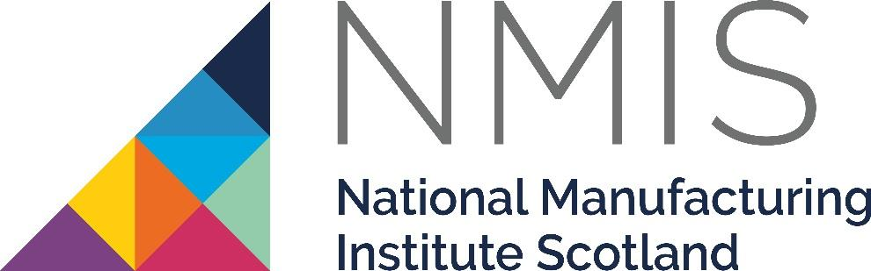

Please read the conditions of entry and guidance notes carefully before completing this form.

**Closing date: 19th SEPT**

# 

# Excellence in Manufacturing Award

This award is aimed at companies who can demonstrate business success through excellence in manufacturing.

Organisations will be able to show how they have gained a competitive advantage in their chosen market, by reducing costs, reducing lead times, improving delivery and/or improving product quality. Improvements will have been realised through innovation and technology, the introduction of working practice change and /or the use of lean tools and techniques. Successful organisations will also be able to demonstrate how employees have been engaged in change and improvement, and how the customer has directly benefited.

It would also be expected that the winning company will have a strategy for future growth and improvement and clear plans to implement further change - either through improvement programmes or a demonstrable culture of continuous improvement.

# Conditions of entry & guidance notes

**Entry is free and open to any Renfrewshire Chamber member or non-member businesses who are based in Renfrewshire**

* Please complete the form digitally
* Please email the completed form back to awards@roccoawards.com
* Read the questions and answer concisely.
* Pay attention to word count limits
* Do not copy and paste from company documents or previous submissions
* Do not send in other documents, unless requested
* Submissions may be subject to requests for evidence to maintain the integrity of the awards
* Use evidence, targets and KPIs (Key Performance Indicators) where possible
* Don't use jargon or acronyms/abbreviations
* Relate it to Renfrewshire
* Think what the judges want to see & hear
* Submissions received late will not be entered
* And finally - don’t leave it to the last minute!

# 

# Excellence in Manufacturing Award

**Sponsored By National Manufacturing Institute Scotland**

|  |  |  |  |  |  |  |  |  |  |
| --- | --- | --- | --- | --- | --- | --- | --- | --- | --- |
| **Section 1** | | | | | | | | | |
| **Full name of company:** | | | | | | | **Date company was established:** | | |
| **Main local address:** | | | | | | | | | |
| **Web:** | | | | | | | | | |
| **Name of person form completed by/for:** | | | | | | | | | |
| **Job Title:** | | | | | | | | | |
| **Tel:** | | **Fax:** | | | | **Email:** | | | |
| **Type of organisation: (bold)**  Manufacturing  Service  Retail  Education/Training  Voluntary  Other (Please specify): | | | |  | **Type of company: (bold)**  Limited Company  PLC  Partnership  Association  Sole Trader  Registered Charity  Other (Please specify): | | | | |
| **Number of employees:**  Locally: | | | UK: | | | | | Worldwide: | |
| **Number of employees projections**  2026: | | | 2027: | | | | | | |
| **Annual turnover & profit (if available)** | **Last year** | | |  | **This year** | | | | **Next year** |
| **Turnover** |  | | |  |  | | | |  |
| **Profit** |  | | |  |  | | | |  |
| **Brief description of the organisation / what you do** | | | | | | | | | |
| **Brief description of main products and services** | | | | | | | | | |
| **Principal markets supplied** | | | | | | | | | |
| **Briefly, what is your vision, strategy and key objectives?** | | | | | | | | | |

|  |
| --- |
| **Section 2** |
| **Explain how your manufacturing processes have produced improved customer service levels** |
| **Explain how your processes/techniques improve working practices and enhance profitability** |
| **How have your manufacturing improvements impacted employee productivity?** |
| **How have improvements in manufacturing helped you break into new markets?** |
| **Anything else relevant you wish to share?** |
| **Please include details of any recent awards – include title & date** |
| **Why do you believe that your organisation deserves to win the ROCCO Award for Excellence in Manufacturing (max 250 words)** |

|  |  |
| --- | --- |
| Section 3 | |
| Authorisation: I have read and accepted the rules and guidelines associated with these awards, and enter this submission on my organisation's behalf. | |
| **Name** |  |
| **Title** |  |
| **Signature** |  |

All forms must be completed electronically and returned to [awards@roccoawards.com](mailto:awards@roccoawards.com)

**Closing date: 19th SEPT**

If your application is selected for shortlisting you will be required to present to the judges at some point during the week commencing **3rd November 2025**.

If you have any questions regarding the completion of any aspect of the required information please contact **Bob Grant** on **0141 847 5450** or email [awards@roccoawards.com](mailto:awards@roccoawards.com)