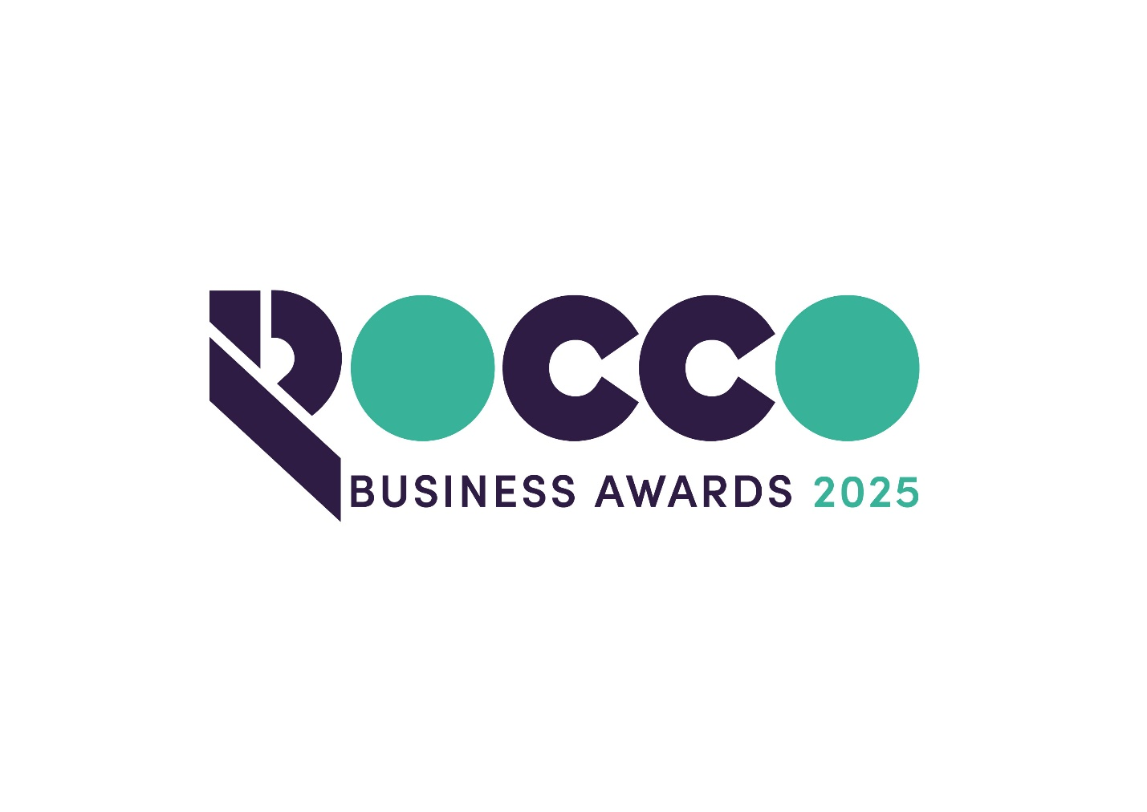

Excellence in Tourism

Sponsored by:
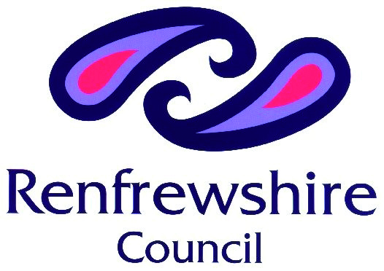

Please read the conditions of entry and guidance notes carefully before completing this form.

Closing date: ENTRY DEADLINE 19th SEPT

Excellence in Tourism Award
Tourism is everybody’s business, and this award is open to any business that welcomes visitors. For example, you may be operating in the hospitality & catering, visitor attraction, leisure, retail or transport sectors.
Applicants must be based in Renfrewshire and be able to demonstrate why their business, product, or service contributes to Renfrewshire’s aspirations to create the very best visitor offer with experiences that exceed expectations.

Conditions of entry & guidance notes
Entry is free and open to any Renfrewshire Chamber member or non-member businesses who are based in Renfrewshire

- Please complete the form digitally
- Please email the completed form back to awards@roccoawards.com
- Read the questions and answer concisely.
- Pay attention to word count limits
- Do not copy and paste from company documents or previous submissions
- Do not send in other documents, unless requested
- Submissions may be subject to requests for evidence to maintain the integrity of the awards
- Use evidence, targets and KPIs (Key Performance Indicators) where possible
- Don't use jargon or acronyms/abbreviations
- Relate it to Renfrewshire
- Think what the judges want to see & hear
- Submissions received late will not be entered
- And finally - don’t leave it to the last minute!

Excellence in Tourism Award
Sponsored By Renfrewshire Council
Section 1
Full name of company: |  |  |  |  |  |  | Date company was established:
Main local address:

Web:
Name of person form completed by/for:
Job Title:
Tel: |  | Fax: |  |  |  | Email:
Type of organisation: (bold)  Manufacturing  Service  Retail  Education/Training  Voluntary  Other (Please specify): |  |  |  |  | Type of company: (bold)  Limited Company  PLC  Partnership  Association  Sole Trader  Registered Charity  Other (Please specify):
Number of employees:  Locally: |  |  | UK: |  |  |  |  | Worldwide:
Number of employees projections  2026: |  |  | 2027:
Annual turnover & profit (if available) | Last year |  |  |  | This year |  |  |  | Next year
Turnover
Profit
Brief description of the organization / what you do

Brief description of main products and services –

Principal markets supplied –

Briefly, what is your vision, strategy and key objectives?

Section 2
Who are your customers and have you experienced visitor growth? Please explain.

How do you ensure that your visitors receive excellent customer service and have a great experience?

How do you manage and incorporate customer feedback? This could range from developing new products to responding to online customer comments.

How do you work with staff to develop their skills?

How do you use digital to engage your visitors and customers? This can include using digital product development to enhance your offering.
How do you engage with other tourism agencies and partners?
Anything else relevant you wish to share?

Why do you believe that your organisation deserves to win the ROCCO Award for Excellence in Tourism (max 250 words)

Section 3
Authorisation: I have read and accepted the rules and guidelines associated with these awards, and enter this submission on my organisation's behalf.
Name
Title
Signature

All forms must be completed electronically and returned to awards@roccoawards.com

Closing date: 19th SEPT

If your application is selected for shortlisting you will be required to present to the judges at some point during the week commencing 3rd November 2025.

If you have any questions regarding the completion of any aspect of the required information please contact Bob Grant on 0141 847 5450 or email awards@roccoawards.com

