

Business Leader of the Year

Sponsored by:
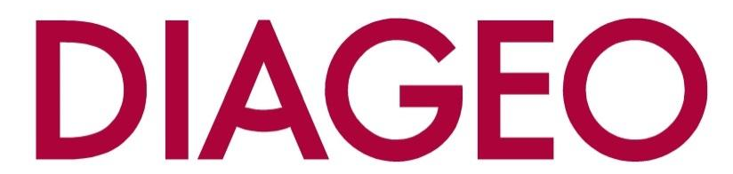

Please read the conditions of entry and guidance notes carefully before completing this form.

NEW EXTENDED Closing date: TUESDAY 30TH SEPTEMBER

Business Leader of the Year Award

This award recognises the leader of a company who has done some or all of the following:
- Led the company through a difficult phase - and came out on top
- Grown the company significantly whether it be by turnover/profit/market share/staff
- Enhanced the profile of the company on a local/national or even global basis
- Through their leadership the company excels in certain areas, such as service or quality
- Enhanced the reputation of Renfrewshire

Conditions of entry & guidance notes
Entry is free and open to any Renfrewshire Chamber member or non-member businesses who are based in Renfrewshire

- Please complete the form digitally
- Please email the completed form back to awards@roccoawards.com
- Read the questions and answer concisely.
- Pay attention to word count limits
- Do not copy and paste from company documents or previous submissions
- Do not send in other documents, unless requested
- Submissions may be subject to requests for evidence to maintain the integrity of the awards
- Use evidence, targets and KPIs (Key Performance Indicators) where possible
- Don't use jargon or acronyms/abbreviations
- Relate it to Renfrewshire
- Think what the judges want to see & hear
- Submissions received late will not be entered
- And finally - don’t leave it to the last minute!

Business Leader of the Year Award
Sponsored By Diageo
Section 1
Full name of company: |  |  |  |  |  |  | Date company was established:
Main local address:

Web:
Name of person form completed by/for:
Job Title:
Tel: |  | Fax: |  |  |  | Email:
Type of organisation: (bold)  Manufacturing  Service  Retail  Education/Training  Voluntary  Other (Please specify): |  |  |  |  | Type of company: (bold)  Limited Company  PLC  Partnership  Association  Sole Trader  Registered Charity  Other (Please specify):
Number of employees:  Locally: |  |  | UK: |  |  |  |  | Worldwide:
Number of employees projections  2026: |  |  | 2027:
Annual turnover & profit (if available) | Last year |  |  |  | This year |  |  |  | Next year
Turnover
Profit
Brief description of the organisation / what you do

Brief description of main products and services

Principal markets supplied

Briefly, what is your vision, strategy and key objectives?

Section 2
Why does this person deserve to win Business Leader of the Year (max 250 words)

Section 3
Authorisation: I have read and accepted the rules and guidelines associated with these awards, and enter this submission on my organisation's behalf.
Name
Title
Signature

All forms must be completed electronically and returned to awards@roccoawards.com
Closing date: 19th SEPT

If you have any questions regarding the completion of any aspect of the required information please contact Bob Grant on 0141 847 5450 or email awards@roccoawards.com

