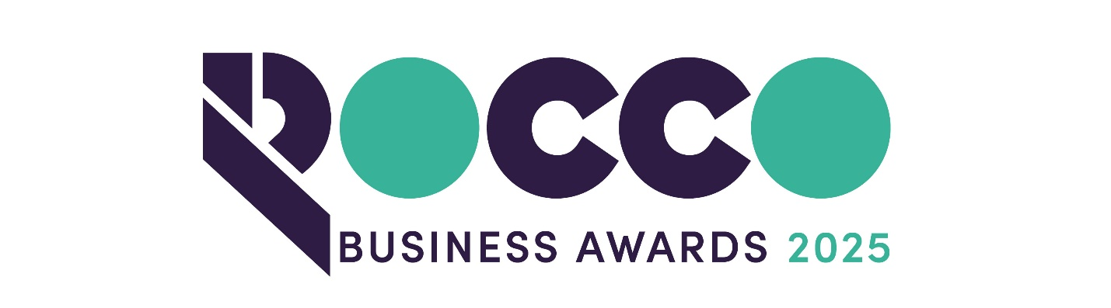

Family Business of the Year

Sponsored by:
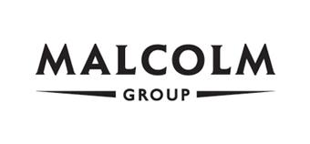
Please read the conditions of entry and guidance notes carefully before completing this form.

NEW EXTENDED Closing date: TUESDAY 30TH SEPTEMBER

Family Business of the Year Award

Open to family businesses (or majority family-owned) – where the family members play a key role in the successful running and growth of the company

Conditions of entry & guidance notes
Entry is free and open to any Renfrewshire Chamber member or non-member businesses who are based in Renfrewshire

- Please complete the form digitally
- Please email the completed form back to awards@roccoawards.com
- Read the questions and answer concisely.
- Pay attention to word count limits
- Do not copy and paste from company documents or previous submissions
- Do not send in other documents, unless requested
- Submissions may be subject to requests for evidence to maintain the integrity of the awards
- Use evidence, targets and KPIs (Key Performance Indicators) where possible
- Don't use jargon or acronyms/abbreviations
- Relate it to Renfrewshire
- Think what the judges want to see & hear
- Submissions received late will not be entered
- And finally - don’t leave it to the last minute!

Family Business of the Year Award
Sponsored By Malcolm Group
Section 1
Full name of company: |  |  |  |  |  |  | Date company was established:
Main local address:

Web:
Name of person form completed by/for:
Job Title:
Tel: |  | Fax: |  |  |  | Email:
Type of organisation: (bold)  Manufacturing  Service  Retail  Education/Training  Voluntary  Other (Please specify): |  |  |  |  | Type of company: (bold)  Limited Company  PLC  Partnership  Association  Sole Trader  Registered Charity  Other (Please specify):
Number of employees:  Locally: |  |  | UK: |  |  |  |  | Worldwide:
Number of employees projections  2026: |  |  | 2027:
Annual turnover & profit (if available) | Last year |  |  |  | This year |  |  |  | Next year
Turnover
Profit
Number of family members employed by the company, including those on board of directors:
Number of generations actively involved since the company was founded:
Number of generations involved in the company at present:
Generation currently running the company (1st, 2nd, 3rd…):
Brief description of the organisation / what you do

Brief description of main products and services

Principal markets supplied

Briefly, what is your vision, strategy and key objectives?

Section 2
How have you successfully linked your family with your business?

Describe the impact the company has had on the community

Has your family developed innovative business practices that have helped the family business succeed from one generation to the next

How do the family's values influence the business?

Is it the family’s intention to pass on the business to future generations? If so, how are major management decisions made, and what succession planning steps have been taken?

Please detail any relevant awards including title & date:

Why do you believe that your organisation deserves to win the ROCCO Award for Family Business of the Year? (max 250 words)

Section 3
Authorisation: I have read and accepted the rules and guidelines associated with these awards, and enter this submission on my organisation's behalf.
Name
Title
Signature

All forms must be completed electronically and returned to awards@roccoawards.com

NEW EXTENDED Closing date: TUESDAY 30TH SEPTEMBER

If your application is selected for shortlisting you will be required to present to the judges at some point during the week commencing 3rd November 2025.

If you have any questions regarding the completion of any aspect of the required information please contact Bob Grant on 0141 847 5450 or email awards@roccoawards.com

