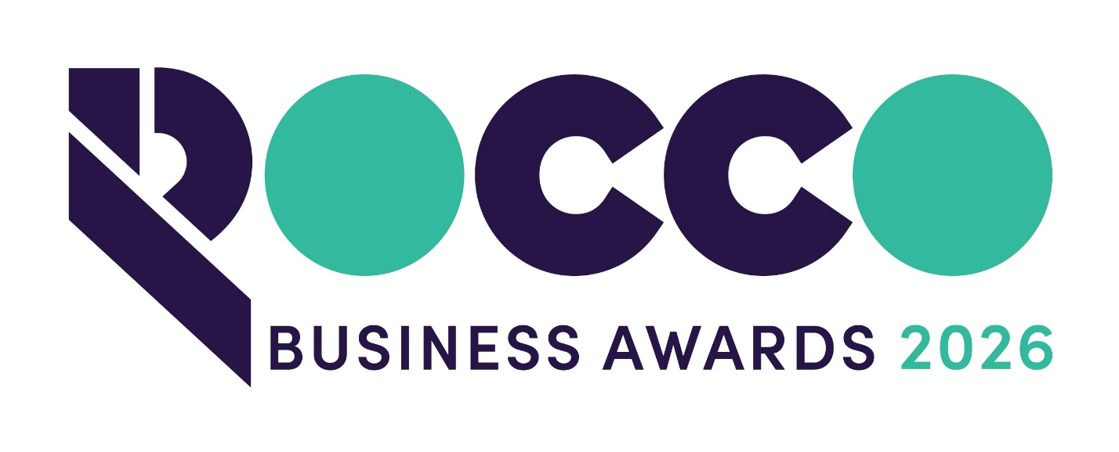

Innovation & Technology

Sponsored by:


Please read the conditions of entry and guidance notes carefully before completing this form.

Closing date: FRIDAY 11TH SEPTEMBER

Innovation & Technology Award

This award is open to businesses which have successfully developed innovative products, technologies or services, or who have developed innovative ways of doing business with customers. Entrants will show a high degree of creativity and dynamism and will be exploring ways to exploit their innovation to its fullest potential.
Successful companies will have developed a product/service or business process that is unique or groundbreaking in their sector and which satisfies a real need in the marketplace.

Conditions of entry & guidance notes
Entry is free and open to any Renfrewshire Chamber member or non-member businesses who are based in Renfrewshire

- Please complete the form digitally
- Please email the completed form back to awards@roccoawards.com
- Read the questions and answer concisely.
- Pay attention to word count limits
- Do not copy and paste from company documents or previous submissions
- Do not send in other documents, unless requested
- Submissions may be subject to requests for evidence to maintain the integrity of the awards
- Use evidence, targets and KPIs (Key Performance Indicators) where possible
- Don't use jargon or acronyms/abbreviations
- Relate it to Renfrewshire
- Think what the judges want to see & hear
- Submissions received late will not be entered
- And finally - don’t leave it to the last minute!

ROCCO Award for Innovation & Technology
Sponsored By University of the West of Scotland
Section 1
Full name of company: |  |  |  |  |  |  | Date company was established:
Main local address:

Web:
Name of person form completed by/for:
Job Title:
Tel: |  | Fax: |  |  |  | Email:
Type of organisation: (bold)  Manufacturing  Service  Retail  Education/Training  Voluntary  Other (Please specify): |  |  |  |  | Type of company: (bold)  Limited Company  PLC  Partnership  Association  Sole Trader  Registered Charity  Other (Please specify):
Number of employees:  Locally: |  |  | UK: |  |  |  |  | Worldwide:
Number of employees projections  2027: |  |  | 2028:
Annual turnover & profit (if available) | Last year |  |  |  | This year |  |  |  | Next year
Turnover
Profit
Brief description of the organisation / what you do

Brief description of main products and services

Principal markets supplied

Briefly, what is your vision, strategy and key objectives?

Section 2
Explain how you have successfully designed/developed new innovative products, technologies, services or ways of doing business

How did you determine whether this would fill a real market need and be worth investment (investment can be time/resource/money etc..)

Explain how commercially successful the product or service has been

What makes the product/service “unique” and/or better than the competition?

Anything else relevant you wish to share?

Please list any relevant awards (date & title)

Why do you believe that your organisation deserves to win the ROCCO Award for Innovation & Technology (max 250 words)

Section 3
Authorisation: I have read and accepted the rules and guidelines associated with these awards, and enter this submission on my organisation's behalf.
Name
Title
Signature

All forms must be completed electronically and returned to awards@roccoawards.com

Closing date: FRIDAY 11TH SEPTEMBER

If your application is selected for shortlisting you will be required to present to the judges at some point during the week commencing 26TH OCTOBER

If you have any questions regarding the completion of any aspect of the required information please contact Bob Grant on 0141 847 5450 or email awards@roccoawards.com

