

Renfrewshire Impact Award

Sponsored by:
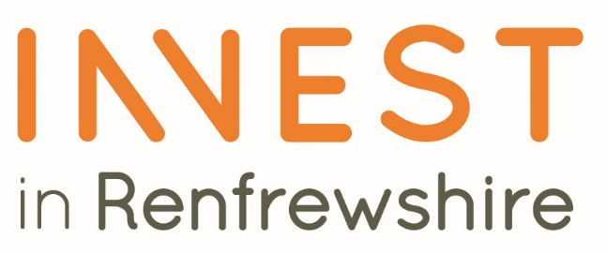

Please read the conditions of entry and guidance notes carefully before completing this form.

Closing date: Friday 11th September

Renfrewshire Impact Award

This award recognises businesses and organisations that are making a deliberate positive difference to Renfrewshire’s communities through the way they thoughtfully invest, employ, buy, support local initiatives and create opportunities for local people.

Open to organisations of all sizes, the award celebrates those who go beyond business as usual to deliver additional economic and social benefits for Renfrewshire. Whether through creating local jobs, supporting local suppliers, investing in communities, developing skills, or making better use of local assets, entrants should demonstrate how their actions contribute to a stronger, fairer and more prosperous local economy.

The award aims to showcase businesses that understand their success is linked to the success of the communities they serve and who are helping ensure that more opportunity, investment and prosperity stays within Renfrewshire.

Applications should provide evidence of impact in one or more of the following areas:

1. Commitment to Supporting Local Businesses and Supply Chains
Using local suppliers and contractors wherever possible, helping local businesses to grow and ensuring that more spending remains within Renfrewshire. This could include responsible procurement practices, community benefit commitments, or developing opportunities for smaller local businesses to access contracts and opportunities.

2. Creating Jobs and Opportunities for Under-Represented Groups
Providing employment, apprenticeships, work placements, training or volunteering opportunities for local unemployed people and those under-represented in the labour market. This may include supporting individuals facing barriers to employment, paying fair wages, investing in workforce development, and creating pathways for career progression.

3. Investing in Communities and Places
Contributing to the improvement of local communities through sponsorship, volunteering, community partnerships, regeneration projects, or making use of vacant or underutilised spaces to create wider community benefit.

Judges will be looking for clear evidence of added value in terms of how the organisation's activities have delivered tangible benefits for local people, communities and the wider Renfrewshire economy.

Conditions of entry & guidance notes
Entry is free and open to any Renfrewshire Chamber member or non-member businesses who are based in Renfrewshire

- Please complete the form digitally
- Please email the completed form back to awards@roccoawards.com
- Read the questions and answer concisely.
- Pay attention to word count limits
- Do not copy and paste from company documents or previous submissions
- Do not send in other documents, unless requested
- Submissions may be subject to requests for evidence to maintain the integrity of the awards
- Use evidence, targets and KPIs (Key Performance Indicators) where possible
- Don't use jargon or acronyms/abbreviations
- Relate it to Renfrewshire
- Think what the judges want to see & hear
- Submissions received late will not be entered
- And finally - don’t leave it to the last minute!

Renfrewshire Impact Award
Sponsored By Renfrewshire Council
Section 1
Full name of company: |  |  |  |  |  |  | Date company was established:
Main local address:

Web:
Name of person form completed by/for:
Job Title:
Tel: |  | Fax: |  |  |  | Email:
Type of organisation: (bold)  Manufacturing  Service  Retail  Education/Training  Voluntary  Other (Please specify): |  |  |  |  | Type of company: (bold)  Limited Company  PLC  Partnership  Association  Sole Trader  Registered Charity  Other (Please specify):
Number of employees:  Locally: |  |  | UK: |  |  |  |  | Worldwide:
Number of employees projections  2026: |  |  | 2027:
Annual turnover & profit (if available) | Last year |  |  |  | This year |  |  |  | Next year
Turnover
Profit
Brief description of the organisation / what you do

Brief description of main products and services

Principal markets supplied

Briefly, what is your vision, strategy and key objectives?

Section 2:
Describe the activities, initiatives or practices your organisation has implemented that have created a positive impact in Renfrewshire. Consider what makes your organisation's approach distinctive or innovative compared to normal business practice?

(Please outline the key actions you have taken and explain how they support local people, communities, businesses or the local economy)

Explain how you engaged with local people, communities, businesses, suppliers or partners to deliver these activities.

Please describe:
- Partnerships developed with local organisations, communities or suppliers
- How local people or stakeholders have influenced your approach
- Any innovative or inclusive practices you have introduced which support positive local outcomes

Describe the impact your organisation's activities have delivered in Renfrewshire and the difference they have made to local people, communities, businesses and the wider local economy.

Please provide both measurable evidence and examples of outcomes achieved
, including where relevant:
- Commitment to other Local Businesses
- Supporting Unemployed and Under-represented groups
- Investing in community support, sponsorship or local investment

How will your organisation continue to contribute to the prosperity, wellbeing and resilience of Renfrewshire in the future?
Please outline:
- Future plans or commitments
- Planned investment
- New initiatives which support the local people, community and economy

Explain why your business deserves to win the Renfrewshire Impact ROCCO Award (max 250 words)
Summarising:
- The most significant difference your organisation has made to Renfrewshire
- What makes your approach distinctive, innovative or impactful
- How your organisation demonstrates a genuine commitment to the long-term success and prosperity of Renfrewshire

Section 3
Authorisation: I have read and accepted the rules and guidelines associated with these awards, and enter this submission on my organisation's behalf.
Name
Title
Signature

All forms must be completed electronically and returned to awards@roccoawards.com

Closing date: FRIDAY 11TH SEPTEMBER

If your application is selected for shortlisting you will be required to present to the judges at some point during the week commencing 26TH OCTOBER.

If you have any questions regarding the completion of any aspect of the required information please contact Bob Grant on 0141 847 5450 or email awards@roccoawards.com

