

Young Business Person of the Year

Sponsored by
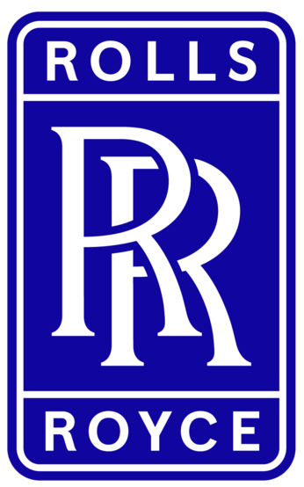

Please read the conditions of entry and guidance notes carefully before completing this form.

Closing date: FRIDAY 11TH SEPTEMBER

Young Business Person of the Year Award
Sponsored by Rolls Royce

This Award is open to individuals aged 35 years old or younger that have established their own business. Entrants should be able to demonstrate how their youth & energy has helped them set up a successful business.

Conditions of entry & guidance notes
Entry is free and open to any Renfrewshire Chamber member or non-member businesses who are based in Renfrewshire

- Please complete the form digitally
- Please email the completed form back to awards@roccoawards.com
- Read the questions and answer concisely.
- Pay attention to word count limits
- Do not copy and paste from company documents or previous submissions
- Do not send in other documents, unless requested
- Submissions may be subject to requests for evidence to maintain the integrity of the awards
- Use evidence, targets and KPIs (Key Performance Indicators) where possible
- Don't use jargon or acronyms/abbreviations
- Relate it to Renfrewshire
- Think what the judges want to see & hear
- Submissions received late will not be entered
- And finally - don’t leave it to the last minute!

Young Business Person of the Year Award
Sponsored By Rolls Royce
Section 1
Full name of company: |  |  |  |  |  |  | Date company was established:
Main local address:

Web:
Name of person form completed by/for:
Job Title: |  |  |  |  | Age:
Tel: |  | Fax: |  |  |  | Email:
Type of organisation: (bold)  Manufacturing  Service  Retail  Education/Training  Voluntary  Other (Please specify): |  |  |  |  | Type of company: (bold)  Limited Company  PLC  Partnership  Association  Sole Trader  Registered Charity  Other (Please specify):
Number of employees:  Locally: |  |  | UK: |  |  |  |  | Worldwide:
Number of employees projections  2027: |  |  | 2028:
Annual turnover & profit (if available) | Last year |  |  |  | This year |  |  |  | Next year
Turnover
Profit
Brief description of the organisation / what you do

Brief description of main products and services

Principal markets supplied

Briefly, what is your vision, strategy and key objectives?

Section 2
Describe why you established the business, your USP and what if any external support was received.

In what ways has your age been a positive factor in your business success?

What barriers have you encountered in your career to date and how have you overcome them?

What are your plans & strategy to grow your business?

Please state any relevant awards/achievements, including award name & date:

Why do you believe you deserve to win the ROCCO Award for Young Business Person of the Year? (max 200 words)

Section 3
Authorisation: I have read and accepted the rules and guidelines associated with these awards, and enter this submission on my organisation's behalf.
Name
Title
Signature

All forms must be completed electronically and returned to awards@roccoawards.com

Closing date: FRIDAY 11TH SEPTEMBER

If your application is selected for shortlisting you will be required to present to the judges at some point during the week commencing 26TH OCTOBER

If you have any questions regarding the completion of any aspect of the required information please contact Bob Grant on 0141 847 5450 or email awards@roccoawards.com

